Experiment – 1

import random

def fitness(x):
return x ** 2

POPULATION_SIZE = 10
CHROMOSOME_LENGTH = 5
MUTATION_RATE = 0.01
CROSSOVER_RATE = 0.8
GENERATIONS = 20

def create_population():
population = []
for _ in range(POPULATION_SIZE):
chromosome = [
random.randint(0, 1)
for _ in range(CHROMOSOME_LENGTH)
]
population.append(chromosome)
return population

def decode(chromosome):
binary_string = ''.join(map(str, chromosome))
return int(binary_string, 2)

def evaluate_population(population):
return [fitness(decode(individual)) for individual in population]

def selection(population, fitness_values):
total_fitness = sum(fitness_values)

if total_fitness == 0:
return random.choice(population)

pick = random.uniform(0, total_fitness)
current = 0

for individual, fit in zip(population, fitness_values):
current += fit
if current >= pick:
return individual.copy()

return population[-1].copy()

def crossover(parent1, parent2):
if random.random() < CROSSOVER_RATE:
point = random.randint(1, CHROMOSOME_LENGTH - 1)
child1 = parent1[:point] + parent2[point:]
child2 = parent2[:point] + parent1[point:]
return child1, child2

return parent1.copy(), parent2.copy()

def mutation(chromosome):
for i in range(CHROMOSOME_LENGTH):
if random.random() < MUTATION_RATE:
chromosome[i] = 1 - chromosome[i]
return chromosome

def genetic_algorithm():
population = create_population()

best_solution = None
best_fitness = float('-inf')

for generation in range(GENERATIONS):
fitness_values = evaluate_population(population)

max_index = fitness_values.index(max(fitness_values))

if fitness_values[max_index] > best_fitness:
best_fitness = fitness_values[max_index]
best_solution = population[max_index].copy()

print(
f"Generation {generation + 1}: "
f"Best x = {decode(best_solution)}, "
f"Fitness = {best_fitness}"
)

new_population = []

while len(new_population) < POPULATION_SIZE:
parent1 = selection(population, fitness_values)
parent2 = selection(population, fitness_values)

child1, child2 = crossover(parent1, parent2)

child1 = mutation(child1)
child2 = mutation(child2)

new_population.append(child1)

if len(new_population) < POPULATION_SIZE:
new_population.append(child2)

population = new_population

print("\nFinal Result")
print("Best chromosome:", best_solution)
print("Best x:", decode(best_solution))
print("Maximum fitness:", best_fitness)

genetic_algorithm()

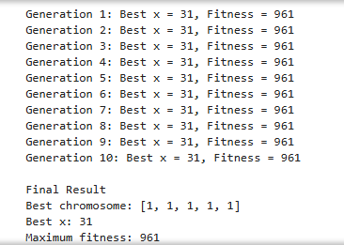

Experiment – 2

import random

def fitness(x):
return x ** 2

NUM_PARTICLES = 10
MAX_ITERATIONS = 20
W = 0.7
C1 = 1.5
C2 = 1.5

MIN_POSITION = -10
MAX_POSITION = 10
MIN_VELOCITY = -2
MAX_VELOCITY = 2

particles = []

for _ in range(NUM_PARTICLES):
position = random.uniform(MIN_POSITION, MAX_POSITION)
velocity = random.uniform(MIN_VELOCITY, MAX_VELOCITY)

particles.append({
"position": position,
"velocity": velocity,
"best_position": position,
"best_fitness": fitness(position)
})

global_best_position = max(
particles,
key=lambda p: p["best_fitness"]
)["best_position"]

global_best_fitness = fitness(global_best_position)

for iteration in range(MAX_ITERATIONS):

for particle in particles:
current_fitness = fitness(particle["position"])

if current_fitness > particle["best_fitness"]:
particle["best_fitness"] = current_fitness
particle["best_position"] = particle["position"]

if current_fitness > global_best_fitness:
global_best_fitness = current_fitness
global_best_position = particle["position"]

for particle in particles:
r1 = random.random()
r2 = random.random()

particle["velocity"] = (
W * particle["velocity"]
+ C1 * r1 * (particle["best_position"] - particle["position"])
+ C2 * r2 * (global_best_position - particle["position"])
)

particle["velocity"] = max(
MIN_VELOCITY,
min(MAX_VELOCITY, particle["velocity"])
)

particle["position"] += particle["velocity"]

particle["position"] = max(
MIN_POSITION,
min(MAX_POSITION, particle["position"])
)

print(
f"Iteration {iteration + 1}: "
f"Best x = {global_best_position:.4f}, "
f"Fitness = {global_best_fitness:.4f}"
)

print("\nFinal Result")
print("Best Position:", global_best_position)
print("Best Fitness:", global_best_fitness)

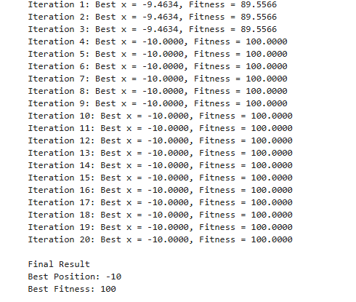

Experiment - 7

import random
import math

cities = {
"A": (10, 20),
"B": (30, 40),
"C": (50, 10),
"D": (70, 30),
"E": (60, 60),
}

city_names = list(cities.keys())

def distance(city1, city2):
x1, y1 = cities[city1]
x2, y2 = cities[city2]
return math.sqrt((x2 - x1) ** 2 + (y2 - y1) ** 2)

def route_distance(route):
total_distance = 0

for i in range(len(route)):
city1 = route[i]
city2 = route[(i + 1) % len(route)]
total_distance += distance(city1, city2)

return total_distance

def create_population(population_size):
population = []

for _ in range(population_size):
route = city_names.copy()
random.shuffle(route)
population.append(route)

return population

def fitness(route):
return 1 / route_distance(route)

def selection(population, tournament_size=5):
tournament = random.sample(population, tournament_size)
return min(tournament, key=route_distance)

def crossover(parent1, parent2):
size = len(parent1)
start, end = sorted(random.sample(range(size), 2))

child = [None] * size
child[start:end] = parent1[start:end]

remaining = [city for city in parent2 if city not in child]

index = 0

for i in range(size):
if child[i] is None:
child[i] = remaining[index]
index += 1

return child

def mutation(route, mutation_rate=0.02):
route = route.copy()

if random.random() < mutation_rate:
index1, index2 = random.sample(range(len(route)), 2)
route[index1], route[index2] = route[index2], route[index1]

return route

def genetic_algorithm(
population_size=50,
generations=100,
mutation_rate=0.02
):
population = create_population(population_size)

best_route = None
best_distance = float("inf")

for generation in range(generations):
population = sorted(population, key=route_distance)

current_best = population[0]
current_distance = route_distance(current_best)

if current_distance < best_distance:
best_route = current_best.copy()
best_distance = current_distance

elite_size = population_size // 10
new_population = population[:elite_size]

while len(new_population) < population_size:
parent1 = selection(population)
parent2 = selection(population)

child = crossover(parent1, parent2)
child = mutation(child, mutation_rate)

new_population.append(child)

population = new_population

if (generation + 1) % 50 == 0:
print(
f"Generation {generation + 1}: "
f"Distance = {best_distance:.2f}"
)

return best_route, best_distance

best_route, best_distance = genetic_algorithm()

print("\nBest Route:")
print(" -> ".join(best_route + [best_route[0]]))

print("\nTotal Distance:")
print(round(best_distance, 2))

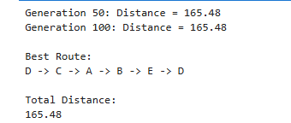

Experiment – 3

import numpy as np

distances = np.array([
[0, 10, 15, 20],
[10, 0, 35, 25],
[15, 35, 0, 30],
[20, 25, 30, 0]
], dtype=float)

n = len(distances)
n_ants = 10
n_iterations = 10
alpha = 1
beta = 2
rho = 0.5
q = 100

pheromone = np.ones((n, n))
heuristic = 1 / (distances + 1e-10)
np.fill_diagonal(heuristic, 0)

best_tour = None
best_length = float('inf')

for iteration in range(n_iterations):
tours = []
lengths = []

for ant in range(n_ants):
start = np.random.randint(n)
tour = [start]
visited = {start}

while len(tour) < n:
current = tour[-1]

probabilities = (
pheromone[current] ** alpha
* heuristic[current] ** beta
)

for city in visited:
probabilities[city] = 0

probabilities /= probabilities.sum()
next_city = np.random.choice(n, p=probabilities)

tour.append(next_city)
visited.add(next_city)

tour.append(start)

length = sum(
distances[tour[i]][tour[i + 1]]
for i in range(n)
)

tours.append(tour)
lengths.append(length)

if length < best_length:
best_length = length
best_tour = tour.copy()

pheromone *= (1 - rho)

for tour, length in zip(tours, lengths):
deposit = q / length

for i in range(n):
a, b = tour[i], tour[i + 1]
pheromone[a][b] += deposit
pheromone[b][a] += deposit
print("Best Tour in ",iteration," iteration:",best_tour)
print("Shortest Distance in ",iteration," iteration:",best_length)
print("Best Tour:", best_tour)
print("Shortest Distance:", best_length)

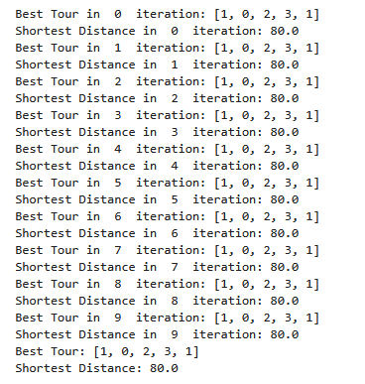

Experiment – 5

import numpy as np
import matplotlib.pyplot as plt

vehicles = np.array([25, 40, 15, 30])

cycle_time = 120
lower = 10
upper = 60

wolves = 20
iterations = 10

def fitness(green):
congestion = np.sum((vehicles / green) ** 2)

penalty = 5 * (np.sum(green) - cycle_time) ** 2

return congestion + penalty

X = np.random.uniform(
lower, upper, (wolves, 4)
)

alpha_score = float("inf")
beta_score = float("inf")
delta_score = float("inf")

alpha = np.zeros(4)
beta = np.zeros(4)
delta = np.zeros(4)

curve = []

for t in range(iterations):

for i in range(wolves):

X[i] = np.clip(X[i], lower, upper)

score = fitness(X[i])

if score < alpha_score:
delta_score = beta_score
delta = beta.copy()

beta_score = alpha_score
beta = alpha.copy()

alpha_score = score
alpha = X[i].copy()

elif score < beta_score:
delta_score = beta_score
delta = beta.copy()

beta_score = score
beta = X[i].copy()

elif score < delta_score:
delta_score = score
delta = X[i].copy()

a = 2 - 2 * t / iterations

for i in range(wolves):

r1 = np.random.rand(4)
r2 = np.random.rand(4)

A1 = 2 * a * r1 - a
C1 = 2 * r2
D1 = abs(C1 * alpha - X[i])
X1 = alpha - A1 * D1

r1 = np.random.rand(4)
r2 = np.random.rand(4)

A2 = 2 * a * r1 - a
C2 = 2 * r2
D2 = abs(C2 * beta - X[i])
X2 = beta - A2 * D2

r1 = np.random.rand(4)
r2 = np.random.rand(4)

A3 = 2 * a * r1 - a
C3 = 2 * r2
D3 = abs(C3 * delta - X[i])
X3 = delta - A3 * D3

X[i] = np.clip(
(X1 + X2 + X3) / 3,
lower, upper
)

curve.append(alpha_score)

print("\nOPTIMIZED TRAFFIC SIGNAL TIMINGS")

for i in range(4):
print(
f"Road {i+1}: "
f"{alpha[i]:.2f} seconds"
)

print("\nTotal Green Time:", round(np.sum(alpha), 2))
print("Minimum Fitness:", round(alpha_score, 4))

normal = np.array([30, 30, 30, 30])

print("\nEqual Timing Fitness:", round(fitness(normal), 4))
print("GWO Optimized Fitness:", round(alpha_score, 4))

plt.figure(figsize=(8, 5))

plt.plot(curve, color="blue", linewidth=2)

plt.xlabel("Iterations")
plt.ylabel("Fitness Value")
plt.title("GWO Traffic Signal Optimization")

plt.grid()
plt.show()

plt.figure(figsize=(8, 5))

plt.bar(
["Road 1", "Road 2", "Road 3", "Road 4"],
alpha,
color=["red", "green", "orange", "blue"]
)

plt.xlabel("Traffic Roads")
plt.ylabel("Green Signal Time (seconds)")
plt.title("Optimized Traffic Signal Timings")

plt.show()
OPTIMIZED TRAFFIC SIGNAL TIMINGS
Road 1: 15.27 seconds
Road 2: 37.05 seconds
Road 3: 36.39 seconds
Road 4: 31.13 seconds

Total Green Time: 119.84
Minimum Fitness: 5.0716

Equal Timing Fitness: 3.7222
GWO Optimized Fitness: 5.0716

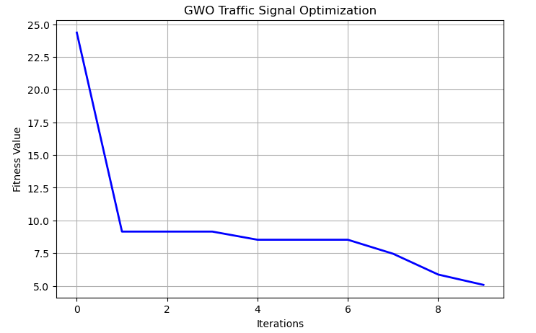

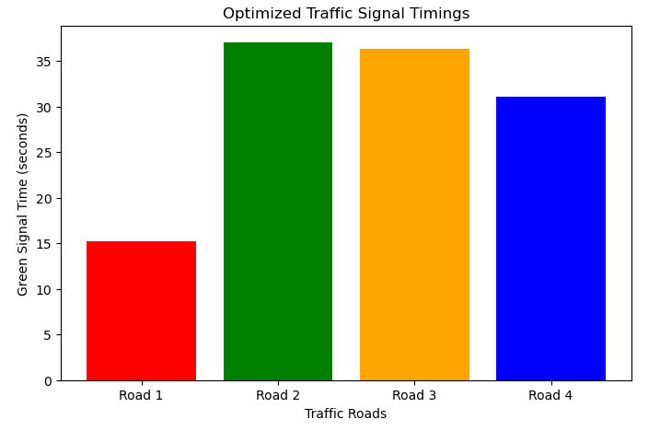

Experiment – 4:

import numpy as np

weights = np.array([2, 3, 4, 5, 9, 7, 6, 8])
profits = np.array([3, 4, 5, 8, 10, 7, 9, 11])

capacity = 20
n_items = len(weights)

n = 25
Pa = 0.25
max_iter = 20
alpha = 0.01
beta = 1.5

def fitness(solution):

total_weight = np.sum(solution * weights)
total_profit = np.sum(solution * profits)

if total_weight > capacity:
return 0

return total_profit

def levy_flight(beta):

sigma = (
np.math.gamma(1 + beta) *
np.sin(np.pi * beta / 2) /
(
np.math.gamma((1 + beta) / 2) *
beta * 2 ** ((beta - 1) / 2)
)
) ** (1 / beta)

u = np.random.normal(0, sigma)
v = np.random.normal(0, 1)

step = u / abs(v) ** (1 / beta)

return step

def binary_conversion(position):

sigmoid = 1 / (1 + np.exp(-np.clip(position, -50, 50)))

return (np.random.rand(n_items) < sigmoid).astype(int)

nests = np.random.randint(0, 2, (n, n_items))

for i in range(n):

while np.sum(nests[i] * weights) > capacity:
selected = np.where(nests[i] == 1)[0]

if len(selected) == 0:
break

nests[i, np.random.choice(selected)] = 0

fitness_values = np.array([fitness(x) for x in nests])

best_index = np.argmax(fitness_values)

best_solution = nests[best_index].copy()
best_fitness = fitness_values[best_index]

for iteration in range(max_iter):

for i in range(n):

step = levy_flight(beta)

position = nests[i] + alpha * step * (
best_solution - nests[i]
)

new_solution = binary_conversion(position)

while np.sum(new_solution * weights) > capacity:

selected = np.where(new_solution == 1)[0]

if len(selected) == 0:
break

new_solution[np.random.choice(selected)] = 0

new_fitness = fitness(new_solution)

j = np.random.randint(0, n)

if new_fitness > fitness_values[j]:

nests[j] = new_solution.copy()
fitness_values[j] = new_fitness

abandon_count = int(Pa * n)

worst_indices = np.argsort(fitness_values)[:abandon_count]

for j in worst_indices:

nests[j] = np.random.randint(0, 2, n_items)

while np.sum(nests[j] * weights) > capacity:

selected = np.where(nests[j] == 1)[0]

if len(selected) == 0:
break

nests[j, np.random.choice(selected)] = 0

fitness_values[j] = fitness(nests[j])

current_best = np.argmax(fitness_values)

if fitness_values[current_best] > best_fitness:

best_fitness = fitness_values[current_best]
best_solution = nests[current_best].copy()

print(
f"Iteration {iteration + 1}: "
f"Best Profit = {best_fitness}"
)

total_weight = np.sum(best_solution * weights)
total_profit = np.sum(best_solution * profits)

print("\n========== FINAL RESULT ==========")

print("Selected Items:", best_solution)

print("Selected Item Numbers:",
np.where(best_solution == 1)[0] + 1)

print("Total Weight:", total_weight)

print("Total Profit:", total_profit)

print("Knapsack Capacity:", capacity)

Output:

Iteration 1: Best Profit = 29
Iteration 2: Best Profit = 29
Iteration 3: Best Profit = 29
Iteration 4: Best Profit = 29
Iteration 5: Best Profit = 29
Iteration 6: Best Profit = 29
Iteration 7: Best Profit = 29
Iteration 8: Best Profit = 29
Iteration 9: Best Profit = 29
Iteration 10: Best Profit = 29
Iteration 11: Best Profit = 29
Iteration 12: Best Profit = 29
Iteration 13: Best Profit = 29
Iteration 14: Best Profit = 29
Iteration 15: Best Profit = 29
Iteration 16: Best Profit = 29
Iteration 17: Best Profit = 29
Iteration 18: Best Profit = 29
Iteration 19: Best Profit = 29
Iteration 20: Best Profit = 29

========== FINAL RESULT ==========
Selected Items: [1 1 1 1 0 0 1 0]
Selected Item Numbers: [1 2 3 4 7]
Total Weight: 20
Total Profit: 29
Knapsack Capacity: 20

